Republic of Albania
Council of Ministers
The Minister of State Innovation and Public Administration
Nr. ____ protocol. Tirana, on 5.2.2016

Manual

Nr. 3 date 2.2.2016

"ON CERTIFICATION OF THE COPY IN THE PAPER OF THE ELECTRONIC DOCUMENT
THROUGH THE ESTABLISHMENT OF ONE OR MORE DYNAMIC CODES FROM PUBLIC INSTITUTIONS"
Pursuant to Article 102, paragraph 4 of the Constitution of the Republic of Albania, Article 10 and
Article 21 of Law 10273/2010 "On Electronic Document", as amended, the Minister of State for Innovation and Public Administration
Instructs :

- The authority responsible for issuing a copy of the electronic document with twodimensional codes is the institution that creates the electronic document in accordance with the requirements of Law 10273/2010 "Electronic Documentation".
- Copy of the electronic document paper is the external form of electronic document submission.
- The copy of the electronic document paper may contain one or more two-dimensional codes, according to the specifications of Annex 1.
- Two-dimensional codes are placed in clearly visible outer form of the document and contain:
    - all external form data of the document, electronic signature, electronic stamp, or both together, as document specification;
    - or an extract of the electronic document only with the most important data.
- The integrity and authenticity of the content of the two-dimensional code should be guaranteed by techniques such as, for example, the technical specifications set forth in RFC 2104. The electronic document issuing institution, which contains two-dimensional codes that includes all the information contained in that document, according to point 5 / a above, must provide free software applications that are easily accessible to reading and decoding twodimensional codes so that the recipient of the document is able to convert the two-dimensional code / codes in the outer form of the electronic document submission.
6.In the case where two-dimensional codes contain an extract of the document and not all the data contained therein, according to point 5 / b above, at least they should include: a. Name of legal person, issuing institution;
  - NIPT of the issuing institution;
  - In the case of services provided by the state administration, it should contain the unique code of service according to the codification regulated by the Instruction of the Minister of State for Innovation and Public Administration Nr. 3477, dated 22.07.2015, "On the methodology of classification, codification and application forms of services provided by the state administration";
  - The title (type) of the document;
  - Date and time of issue of the document;
  - Protocol number of the sending institution (if applicable);
  - The electronic address at which the electronic document can be accessed over its lifecycle, the
URI according to RFC specifications 3986;
  - Unique document identification number;
  - Information on the validity of the electronic document, which is maintained for a period of time according to the rules of each institution and legislation
Archives, but no less than 3 (three) years;
- The head of each institution who receives a copy of the electronic document accompanied by a two-dimensional code, which contains extract of the electronic document under point 5 / b above, authorizes the employee to certify compliance with the electronic document. These employees, through the paper copy of the electronic document and the two-dimensional code attached to it, access the original electronic document stored online through the issuing institution's information systems. The electronic document can further be used to verify the accuracy of the data contained in the copy on paper, or convert it from the electronic form in paper format (printed) by the authorized employee.
- The copy of the electronic document paper shall have the same legal value as the electronic document when realized in accordance with Article 10 of Law 10273/2010 "Electronic Documentary" and this Instruction.
- A copy of the document certified as a copy of the electronic document, obtained from twodimensional codes containing the extract of the document, shall contain the elements and the attachment to Annex 2 (attached). This note is securely attached to the paper copy of the electronic document.
- A copy of the electronic document paper shall be handled in accordance with the requirements of the Archives Act and the technical-professional and methodological norms of the archival service inThe Republic of Albania.
This Instruction enters into force after its publication in the "Official Notebook".

The Minister of State Innovation and
Public Administration

MILENA HARITO ANNEX I

Typologies of two-dimensional codes

Two-dimensional technologies that contain graphically displayed information on a flat surface have evolved from traditional barcodes, but unlike the latter, two-dimensional codes contain information in two dimensions rather than linearly (one-dimensional)

Depending on the type and amount of information contained in two-dimensional codes, more appropriate codes can be selected to perform the necessary functions.

Some of the two-dimensional code types are as follows:

PDF417
PDF417 is a graphic symbol based on OpenSource libraries according to SSH * EN ISO / IEC15438: 2010 specifications.

Such a code may contain 2710 digits or 1850 alphanumeric characters. One or more such codes can be attached to the document to increase the information content contained in linking mechanisms (Macro PDF 417).

MAXICODE

The Maxicode code has a quad view and can contain 93 character information. Can be used in series up to 8 such codes to extend the amount of information contained. These types of codes are also opensource and can be used for free.

DATAMATRIX–ECC200
DataMatrix can contain theoretically up to 2335 alphanumeric characters or 31156 numeric characters or 1556 bytes.

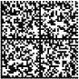

DataMatrix and its generation and encoding techniques are specified in the Albanian Standard DS ** CWA ISO / IEC (16022: 2009) or its equivalents.

DATAGLYPH

This is a kind of codification that contains glifw (lines with 45° incline, '/'d h e'\'),to which we can attribute a binary value '0'or‘1’.

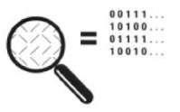

In the maximal size 769 x769glife, Dataglyph can contain up to 63740byte.

QRCODE

QuickResponseCode is a two-dimension code that can contain up to 7089 numeric characters, or
4296 alphanumeric caracters.

Since 2006 QR Code is regulated basing on Albanian Standard SSH ISO/IEC18004:2015 or its equivalent.

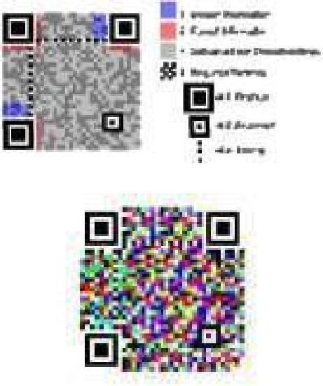

QR Code is usually offered in black-and-white format, but recently can be used codes containing colors (8 or 16 different colors) to increase the amount of information contained in a specific surface of this code.

2D – PLUS

This type of code is created based on a commercial patent in 2004,patent which is useful in USA and Europe.A free application used for decoding purposes for this kind of code exists today.

The data contained in it is in binary form.

WRCode

WR Codeis also a type of two-dimensional code with a commercial licence.This type of code can contain a vast amount of information per centimeter squared in an average resolution of 300 dpi.

A free application is available to use for WR Code reading purposes.

It is possible to codify any kind of information existing in a code like this,as well as changing graphic density.

* Albanian Standard refers to every documet approved by the General Directory of Standardization ,in accordance with section 3 of9870/2008 law “For Standardization”,which is changed and marked as SSH.

** Standardization document is every document,approved by the General Directory of Standardization,in accordance with technical specifications,technicalreports,manuals or special technical agreements, which is offered to the public to use and is marked as DS.

Republic of Albania

Prot. No. ____ Location/day/month/year

Content :Confirmation of paper copy of electrocin document

Confirmation

Based on 1/a point, section10,of law no. 10273, date 29.4.2010 “For electronic documentation”, and Instruction no.___ , date____.____.2015,of Minister of State for Innovation and Public Administration, according to the authorization no.____, date____.____.______,released from Mr./Msz._______________________, (institution titular)_________________, approve that, this copy is:

“The same copy as electronic document”

Title/Description of the document:_____________

Number of pages of the document:______________ (me numra dhe shkronja)

The authorised:

(Duty label) (Name,Surname) (Authorised Person Signature) (Institution Seal)

Page 1 of 1

